- The Monetary Policy Committee's decision to keep Bank Rate at 4% was no surprise. The minutes made no effort to prepare the ground for a November cut and emphasised that the upside risks to medium-term inflationary pressures were dominating the MPC's thinking. We expect Bank Rate to be held at 4% through the rest of this year, before rate cuts resume slowly in 2026.
- The MPC also voted to slow quantitative tightening, reducing gilt holdings by £70bn over the next year, down from £100bn in the previous year. The move was in line with expectations, with the MPC keen to avoid triggering a renewed rise in gilt yields. This was also the motivation behind the Bank of England's decision to focus gilt sales more on shorter maturities.
Since the start of the rate cutting cycle, the Bank of England's Monetary Policy Committee has cut Bank Rate at alternate meetings. Coupled with the MPC's hawkish messaging at the August meeting and a lack of dovish surprises in recent data, this meant a majority vote to keep interest rates unchanged was virtually certain at this week's meeting. And so it proved, with a 7-2 vote to keep Bank Rate at 4%.
Given the lack of jeopardy around September's interest rate decision, attention was instead focused on the MPC's annual quantitative tightening decision. The committee voted 7-2 to lower the stock of gilts held in the asset purchase facility by £70bn from October 2025 to September 2026.
This is a slower pace of QT than in each of the two previous years, when the stock of gilts was reduced by £100bn. After recent volatility in the gilt market, the MPC was keen to avoid surprising markets and chose a number close to the consensus expectation for a £72bn reduction reported in the BoE's recent Market Participants Survey (MaPS). Furthermore, with redemptions expected to shrink to £49bn in 2025-2026, maintaining the previous pace of QT would have required £51bn of active sales over the next year – a near-fourfold increase on the £13bn of active sales seen in 2024-2025. Instead, active sales are set to rise more modestly to £21bn over the next year (Chart 1).
Chart 1: Fewer redemptions mean active gilt sales are expected to rise to £21bn in 2025-2026
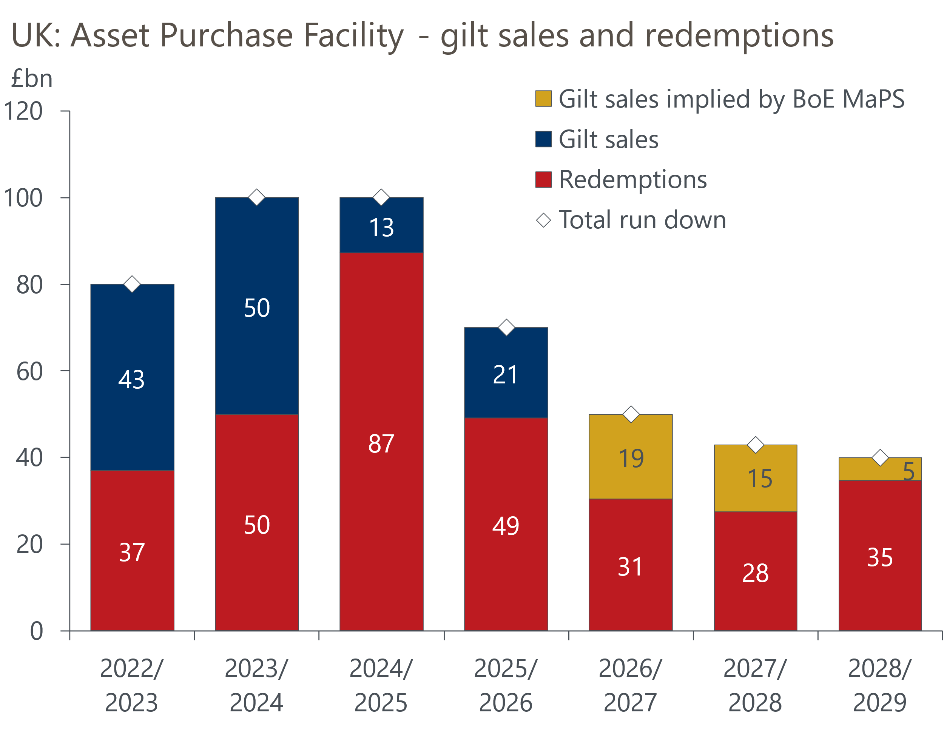
Sources: Oxford Economics calculations using data from Haver Analytics & Bank of England

The BoE also announced the breakdown of active sales will be 40%-40%-20% across short-, medium-, and long-dated gilts, diverging from the previous even split. This was a nod to the recent steepening of the yield curve, with the decision to skew active sales away from longs looking to avoid adding to upward pressure on long-dated gilt yields. We think the MPC's QT decisions emphasise that a majority of committee members are sensitive to prevailing market conditions and aren't wedded to keeping the pace of QT the same each year.
Swinging back to the MPC's interest rate decision, the story was broadly as expected. Alan Taylor and Swati Dhingra voted for a 25bp cut, while the majority voted for a hold and continued to balance the upside risk of above-target inflation persisting with the downside risks from growth and employment.
The minutes reinforced our view that the MPC's concerns about the strength of inflationary pressures are likely to cause it to break the cut-hold pattern in November. Before this week's meeting, market pricing implied just an 11% chance of rates being cut by the November meeting, and there was no attempt to push back on this in the minutes. As we've previously argued, it's hard to see key MPC members, including Governor Andrew Bailey, voting for a cut in the face of such a clear steer from markets. Indeed, Bailey appeared to endorse the market curve telling Bloomberg News "the pricing at the moment, which basically says ‘look, there’s going to be a period where we’re going to be watching very carefully to see how the economy unfolds before whatever we do next in terms of movement’ is, I think, the right thing”.
There was also a new addition to the minutes, with the MPC remarking that "upside risks around medium-term inflationary pressures remain prominent in the committee's assessment of the outlook". This gives the impression that most members are more worried about cutting too quickly than too slowly, reinforcing the sense that a hold is the default outcome for November.
The week also saw the release of the latest labour market and inflation data, and we suspect this will have done little to soothe the MPC's concerns about above-target inflation persisting. CPI inflation held steady at 3.8% in August, but this was largely a result of July's spike in air fares unwinding. The BoE's favoured measure of underlying inflationary pressures in the services sector edged higher in August (Chart 2). The lack of downward momentum in this measure comes despite pay growth continuing to gradually cool, a disconnect that continues to puzzle the MPC. Elsewhere in the labour market release, HMRC's count of payrolled employees fell by just 8,000 in August, after a decline of 6,000 in July, suggesting that the labour market is only loosening very slowly.
Chart 2: Measures of underlying services inflation remain stubbornly high
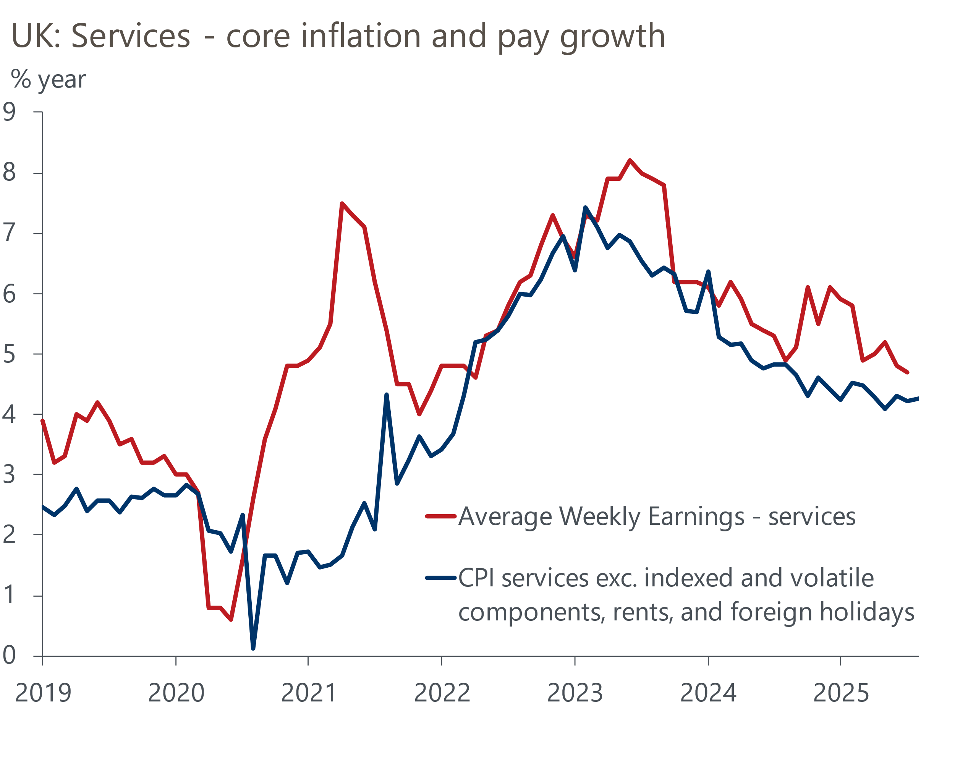
Sources: Oxford Economics calculations using data from Haver Analytics
Overall, we are sticking with our forecast that Bank Rate will remain at 4% for the rest of this year. We think rate cuts will resume in 2026, as the BoE factors in tighter fiscal policy, growth disappoints, and inflation starts to ease. We forecast two 25bp rate cuts in 2026.

The week ahead
August's S&P Global surveys reported a sharp rise in the composite PMI, which took the index to its highest level in a year. We suspect this was largely sentiment-driven in response to news that the US had agreed a range of trade deals, rather than a genuine rise in private sector activity growth. We expect some of August's improvement to have unwound in September, with the composite PMI coming in at 52.5. But the divergence in performance between the services and manufacturing sectors is likely to have remained significant.
Table 1: Week ahead calendar
Date | Events | Period | Measure | Unit | Previous | Forecast
Sep 23 | S&P Global manufacturing | Sep | PMI | % bal | 47.0 | 47.5
Sep 23 | S&P Global services | Sep | PMI | % bal | 54.2 | 53.0
Sep 23 | S&P Global composite | Sep | PMI | % bal | 53.5 | 52.5
Source: Oxford Economics

Key forecasts
Table 2: UK forecast overview
(Annual percentage changes unless specified)
 | 2023 | 2024 | 2025 | 2026 | 2027 | 2028
GDP | 0.4 | 1.1 | 1.3 | 0.9 | 1.3 | 1.7
Private consumption | 0.5 | 0.6 | 1.0 | 1.0 | 1.2 | 1.7
Fixed investment | 0.3 | 1.5 | 1.9 | 1.0 | 1.6 | 2.0
Government consumption | 1.6 | 3.0 | 1.8 | 1.8 | 1.6 | 1.7
Exports of goods and services | -0.4 | -1.2 | 2.9 | 0.8 | 1.2 | 1.4
Imports of goods and services | -1.2 | 2.7 | 4.5 | -0.4 | 1.1 | 1.4
Industrial production | -0.8 | -1.2 | 0.3 | -0.3 | 0.8 | 1.2
Consumer prices | 7.3 | 2.5 | 3.5 | 2.9 | 2.5 | 2.1
Unemployment rate (%) | 4.1 | 4.3 | 4.7 | 4.9 | 4.8 | 4.4
Current a/c balance (% of GDP) | -3.5 | -2.7 | -3.3 | -3.0 | -2.8 | -2.7
Government balance (% of GDP) | 5.2 | 5.1 | 4.5 | 3.6 | 2.9 | 2.6
Central bank policy rate (%, EOP) | 5.25 | 4.75 | 4.00 | 3.50 | 3.00 | 2.75
10yr govt. bond yield (%, EOP) | 3.54 | 4.57 | 4.70 | 4.25 | 3.77 | 3.47
Exchange rate (US$ per £, EOP) | 1.27 | 1.25 | 1.33 | 1.34 | 1.34 | 1.34
Exchange rate (euro per £, EOP) | 1.15 | 1.21 | 1.15 | 1.15 | 1.15 | 1.15
Source: Oxford Economics
Table 3: Quarterly forecasts for the UK
 | 2025 |  |  |  | 2026
 | Q1 | Q2 | Q3 | Q4 | Q1 | Q2 | Q3 | Q4
GDP (% year) | 1.3 | 1.2 | 1.3 | 1.4 | 0.9 | 0.8 | 0.9 | 1.0
CPI inflation (% year) | 2.8 | 3.5 | 3.9 | 3.8 | 3.5 | 2.7 | 2.7 | 2.6
Bank Rate (%, EOP) | 4.50 | 4.25 | 4.00 | 4.00 | 3.75 | 3.75 | 3.50 | 3.50
10yr gilt yield (%, EOP) | 4.70 | 4.48 | 4.75 | 4.70 | 4.66 | 4.54 | 4.40 | 4.25
US$ per £ (EOP) | 1.29 | 1.37 | 1.33 | 1.33 | 1.33 | 1.33 | 1.34 | 1.34
Euro per £ (EOP) | 1.20 | 1.17 | 1.15 | 1.15 | 1.15 | 1.15 | 1.15 | 1.15
Source: Oxford Economics

Latest Country Economic Forecast:
September 16, 2025

Recent publications

Data Insights
Borrowing points to difficult fiscal decisions on the horizon
Retail sales climbed further in August, but the outlook isn't as rosy
Inflation remained stable in August
Labour market shows little sign of generating disinflation
GDP was flat in July and underlying conditions remain weak

Research Briefings
MPC follows path of least resistance on quantitative tightening
MPC preview – Pace and shape of QT is likely to be tweaked
What could prompt the BoE to cut further and/or faster?
Stagflation-lite as policy headwinds increase turbulence
Why is services inflation sticky despite slowing pay growth?

Contacts

Oxford Economics' UK team
- Andrew Goodwin - Chief UK Economist - agoodwin@oxfordeconomics.com
- Edward Allenby - UK Economist - eallenby@oxfordeconomics.com

